How to run ConServe Android App

Using emulator
1. You will need to download Android Studio here
https://developer.android.com/sdk/index.html
There is a mac and a windows version

2. After downloading and installing the studio, it comes with the emulator and you can also view the source code within the IDE. You can go to file → new → project → android project from existing code and then use the included ConServe project. You can also do import → general and select import existing project into workspace
3. After that, you can run the built-in emulator in Android Studio to run the app. When developing the app, we used the Nexus 5 emulator. Click on the play button near the top to launch the emulator and then wait for the emulator to completely start up and run the app

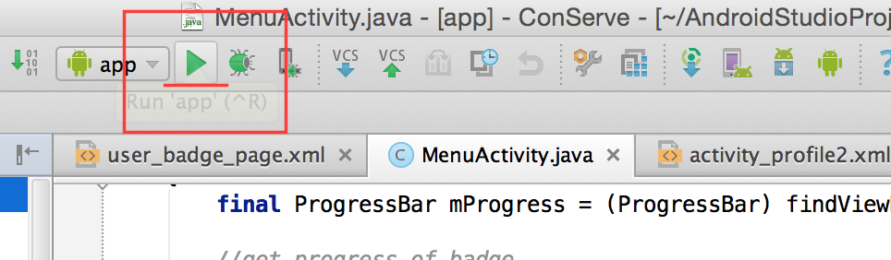
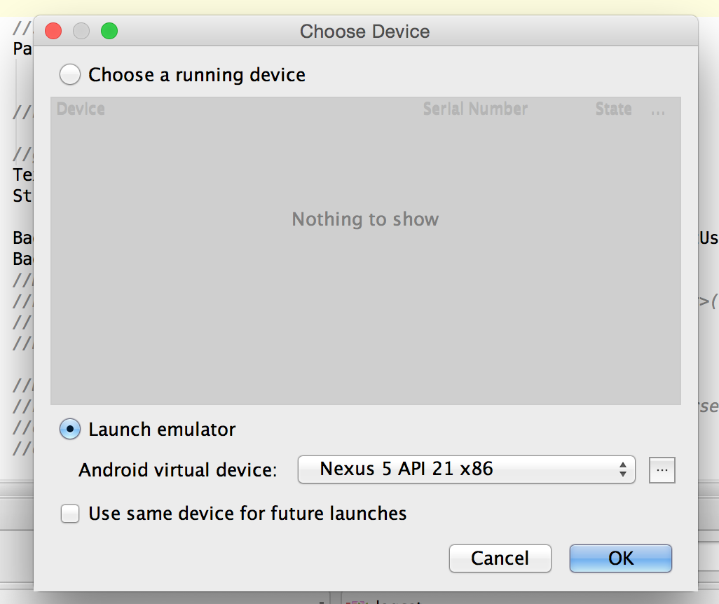

The implementation code is located under /java and the views are located under /layout

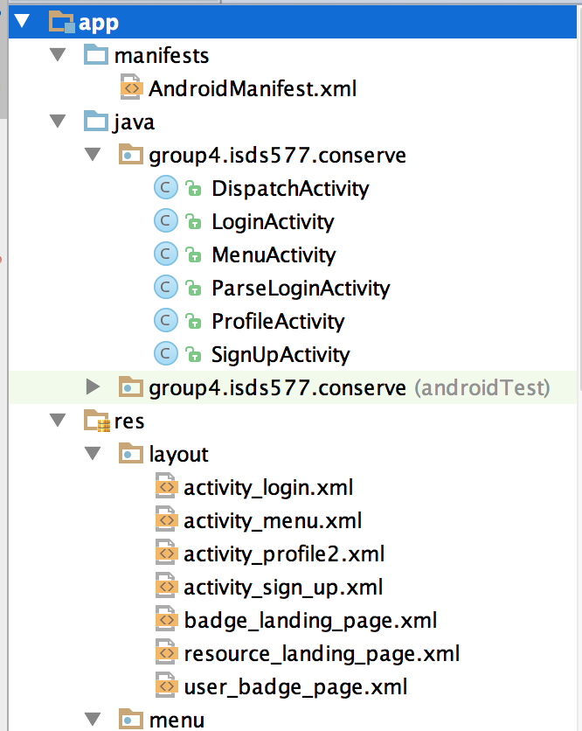
The database files are added as zip files individually, they are exported by Parse in JSON format
References

https://developer.android.com/training/index.html
https://parse.com/tutorials

https://developer.android.com/training/basics/firstapp/building-ui.html

http://developer.android.com/training/basics/firstapp/starting-activity.html

http://www.androidbegin.com/tutorial/android-parse-com-listview-images-and-texts-tutorial/

